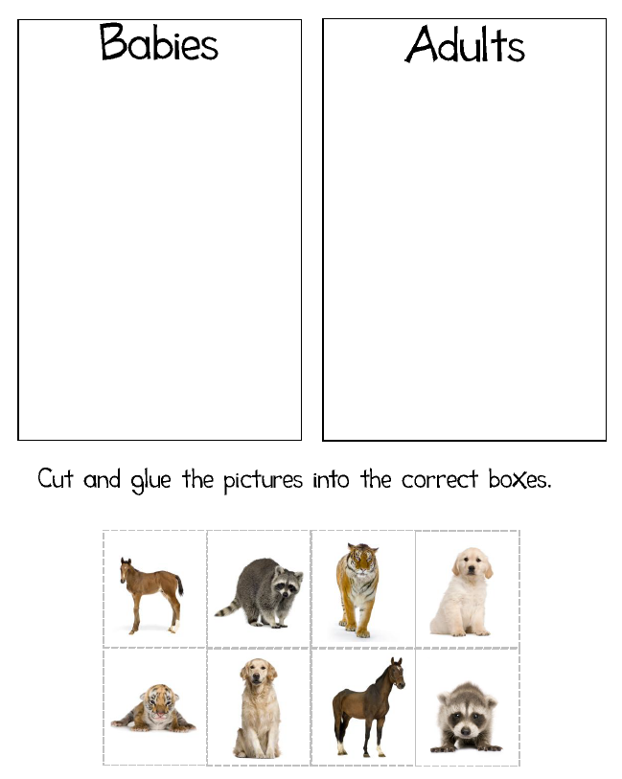

**Name:____________________________________________________ Date:___________**