Name:_______________________________________________ Date:______________

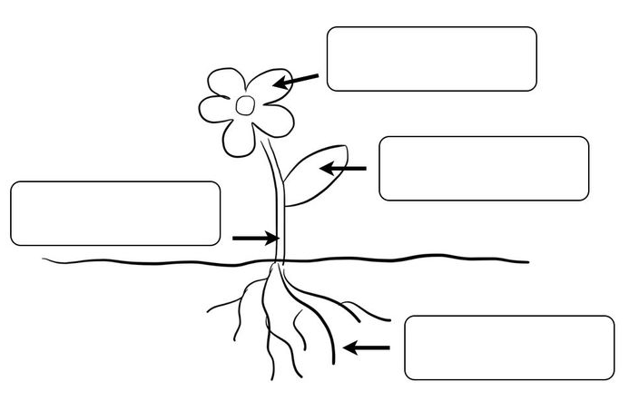
Directions: Label the parts of a plant.

WORD BANK:

Roots
Stem
Leaves
Flower

