**Life Cycles**

Name:_____________________________________________________________ Date:_______________________

**Directions:**

1. Cut out the images below
2. Glue them in the correct life cycle order
3. Describe the life cycle of one animal

I picked the life cycle of a . It starts out as a _____________

_______________________________________________________________________________

________________________________________________________________________________

_____________________________________________________________________________________________________________________________________________________________

________________________________________________________________________________











Life Cycle of a Dog Images

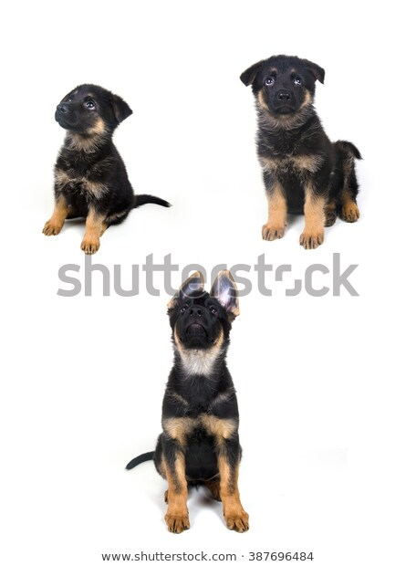

Life Cycle of a Butterfly Images

[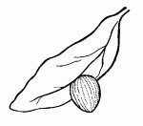](http://bsi.montana.edu/web/kidsbutterfly/coloring/egg)[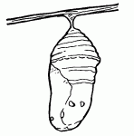](http://bsi.montana.edu/web/kidsbutterfly/coloring/pupa)

[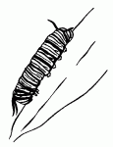](http://bsi.montana.edu/web/kidsbutterfly/coloring/larva)

[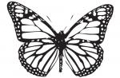](http://bsi.montana.edu/web/kidsbutterfly/coloring/monarch)

Life Cycle of a Chicken Images

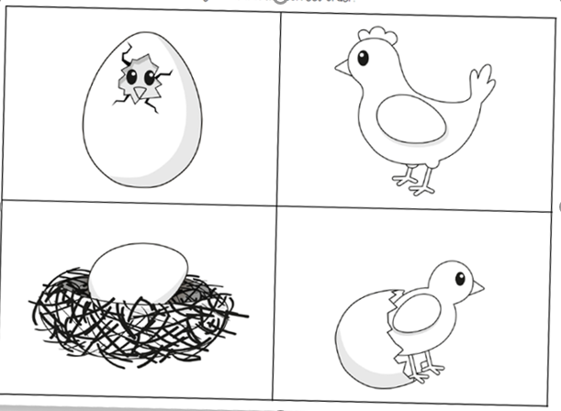

Life Cycle Of A Turtle Images

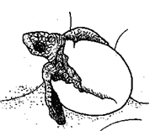

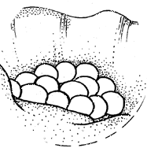

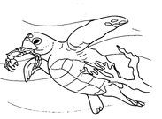

Life Cycle Of A Frog Images:

