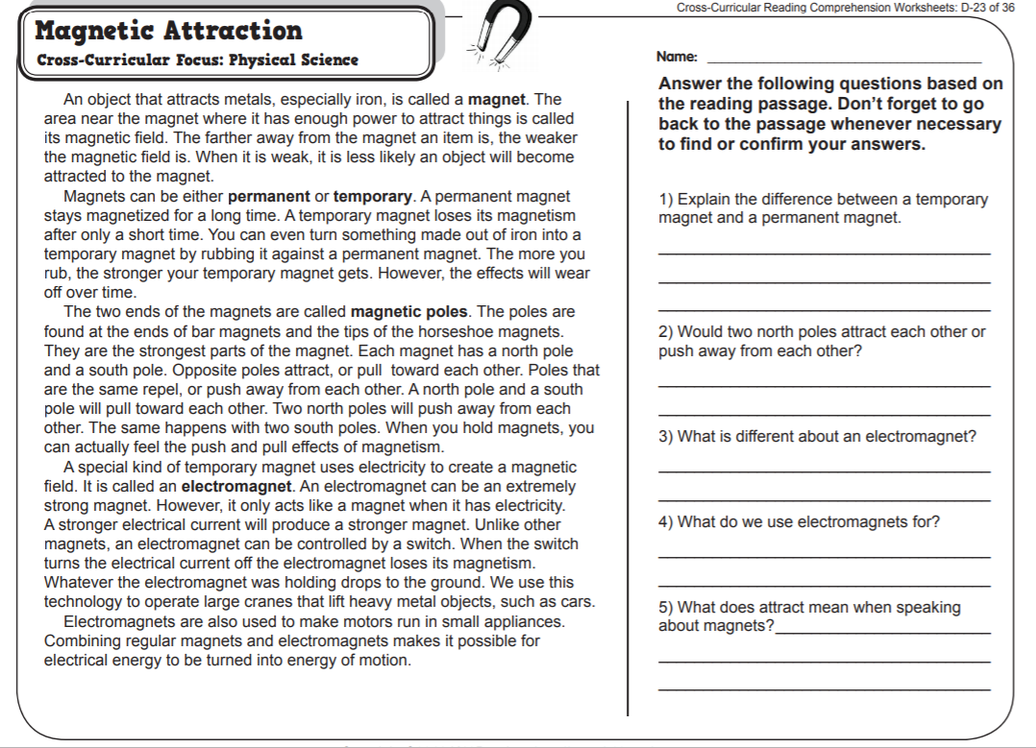

Name:_________________________________________________________ Date:_____________________