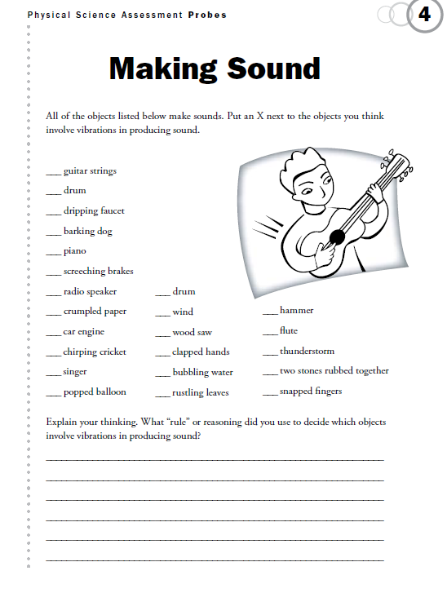

**Name:_______________________________________________ Date:_________________**