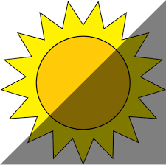
 | Starting Temperature | After 5 Minutes | After 10 Minutes | After 15 Minutes
Cup in the shade
Cup in the sun
I was surprised by…
______________________________________________________________________________________________________

