Name: ___________________________________________________ Date:__________________

Where is the Heat?

Directions: Read and record the temperatures below.
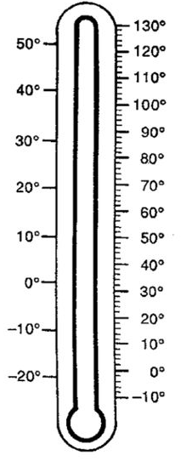

Temperature in the palm of your hand:
Temperature inside your refrigerator.
Temperature outside:
Temperature inside the classroom:

_______ Farmers

_______ Pilots

_______ Chef or Cook

_______ Mechanic

_______ Parent

_______ Nurse or Doctor

A. Need to know the temperature so that they can tell if an engine is overheating or cooling properly
B. Need to know the temperature so that they can predict frost and can cover plants or trees to protect them
C. Need to know the temperature so that they can properly store, cook, and serve food
D. Need to know the temperature so that they can care for animals in severe cold or hot weather
E. Need to know the temperature so that they can dress their children properly for the weather
F. Need to know temperatures to determine if someone has a fever
G. Need to know the temperature so that they can predict dangerous icy conditions on the wings and flaps AND on the ground when they need to take off and land

Exploration:

- Look at your hands and describe how they feel.
__________________________________________________________________________________________
__________________________________________________________________________________________
__________________________________________________________________________________________
__________________________________________________________________________________________

- Now rub your hands together really hard for 30 seconds then look at your hands and describe how they feel.

__________________________________________________________________________________________
__________________________________________________________________________________________
__________________________________________________________________________________________
__________________________________________________________________________________________

- Conduct another friction (rubbing two objects together) experiment and describe it below.

__________________________________________________________________________________________
__________________________________________________________________________________________
__________________________________________________________________________________________
__________________________________________________________________________________________

- Name, draw and describe four sources of heat.

